Running Reports in Virtuous
13-Month Report
Step 1 – Click the blue “Reports” button on the right side of the screen.

Step 2 – Select “13 Month Donor Health” from drop-down selections.
You will notice multiple reports as options. Some default reports like “New Donors” may not produce accurate results due to the settings of our field staff users. Virtuous established these default reports but they do not align with our criteria to ensure these reports are beneficial for you.
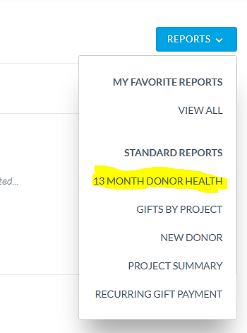

Step 3 – Choose your parameters or leave default settings based on desired results. Note: It defaults to pull the previous month’s data, so if you wish to include the current month, be sure to change the “Month” field. At the calendar year end, you will need to select the prior year to capture data properly. If you have more than one project, either leave the “Project” field blank and it will pull all the projects you own, or you can set a specific project just to see the giving report for that field.
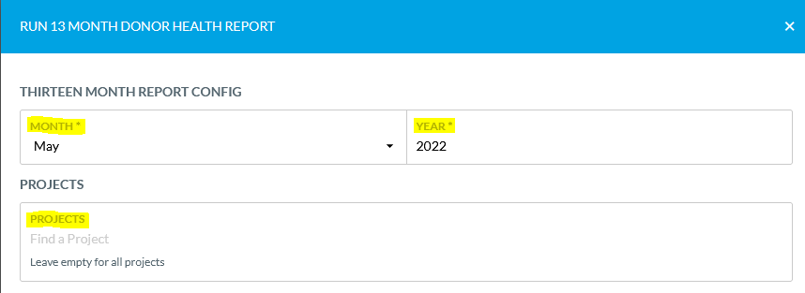
Step 4 – Once paraments are set, click the blue “Run” button at the bottom of screen
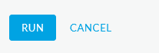

Step 5 – Wait for your results to load. If no results found, you may need to check your data configuration. Once the report loads on your web browser you can either scroll through all the pages; donors are alphabetized and may require clicking the “Next” on the bottom right corner of the results to view additional donors. Or we recommend downloading your report into a XLS (Excel) document. Anonymous donors will be separated from regular donations.
Step 6 – Downloading your results to Excel. Click the blue “Download Report” in the upper right corner of screen and choose the XLS option. Results will follow your computer settings for downloads. It’s important to know your computer/browser settings so you can locate your downloads.
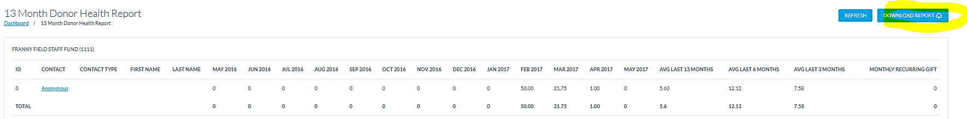
Step 7 – Once your Excel document opens, choose to Enable Editing so you can format your report.
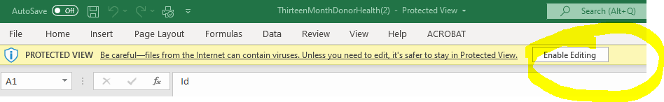

Step 8 – You can delete fields that may be empty or not needed to reduce the configuration of your report. Notice this report lists a column referencing whether the donor has a recurring donation on their account. Donors who have elected to have us debit their account automatically will have their recurring donation amount reflected on the 13-Month Donor Health Report.
If you need to review a specific donor account to see contact information, or passthrough information from conduits, you can either click the hyperlink of the donor’s name within Virtuous or use the search bar to view the individual’s contact record. 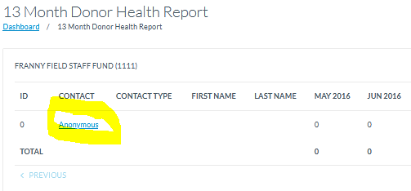
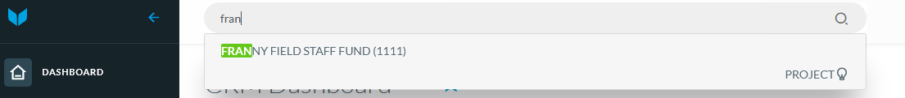

Gifts By Project Report (Use for just a single month view of gifts. Won’t combine totals like 13-Month report will)
Step 1 – Click the blue “Reports” button on the right side of the screen.
Step 2 - Select “Gifts By Project” from drop-down selections.
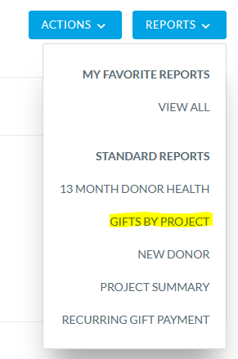

Step 3 – Choose your parameters for your report. For this report, gifts will be listed in order by date based on your parameters. It will not combine a single donor’s gifts within the report. If you leave the “Projects” selection empty, it will pull all projects you are the owner of.
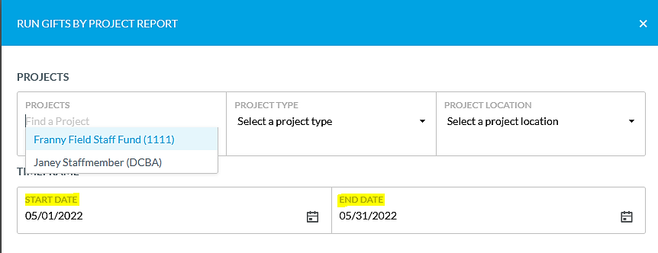
Step 4 – Once parameters are set, click the blue “Run” button at the bottom of screen

Step 5 – Wait for your results to load, if no results are found you may need to check your data configuration. Once the report loads on your web browser, you can either scroll through all the pages; donors are alphabetized and may require clicking the “Next” on the bottom right corner of the results to view additional donors. Or we recommend downloading your report into a XLS (Excel) document. Anonymous donors will be separated from regular donations.

