Returnee Follow-Up Workshop
Presenter: David Larson

Introduction:
- The importance of returnee ministry. (John 15:16—Fruit that will last.)
- Full-cycle vision. The end product of our ministry, the measure of its effectiveness, is reproducing returnees.
- Funnel diagram (another way of portraying the ministry cycle).
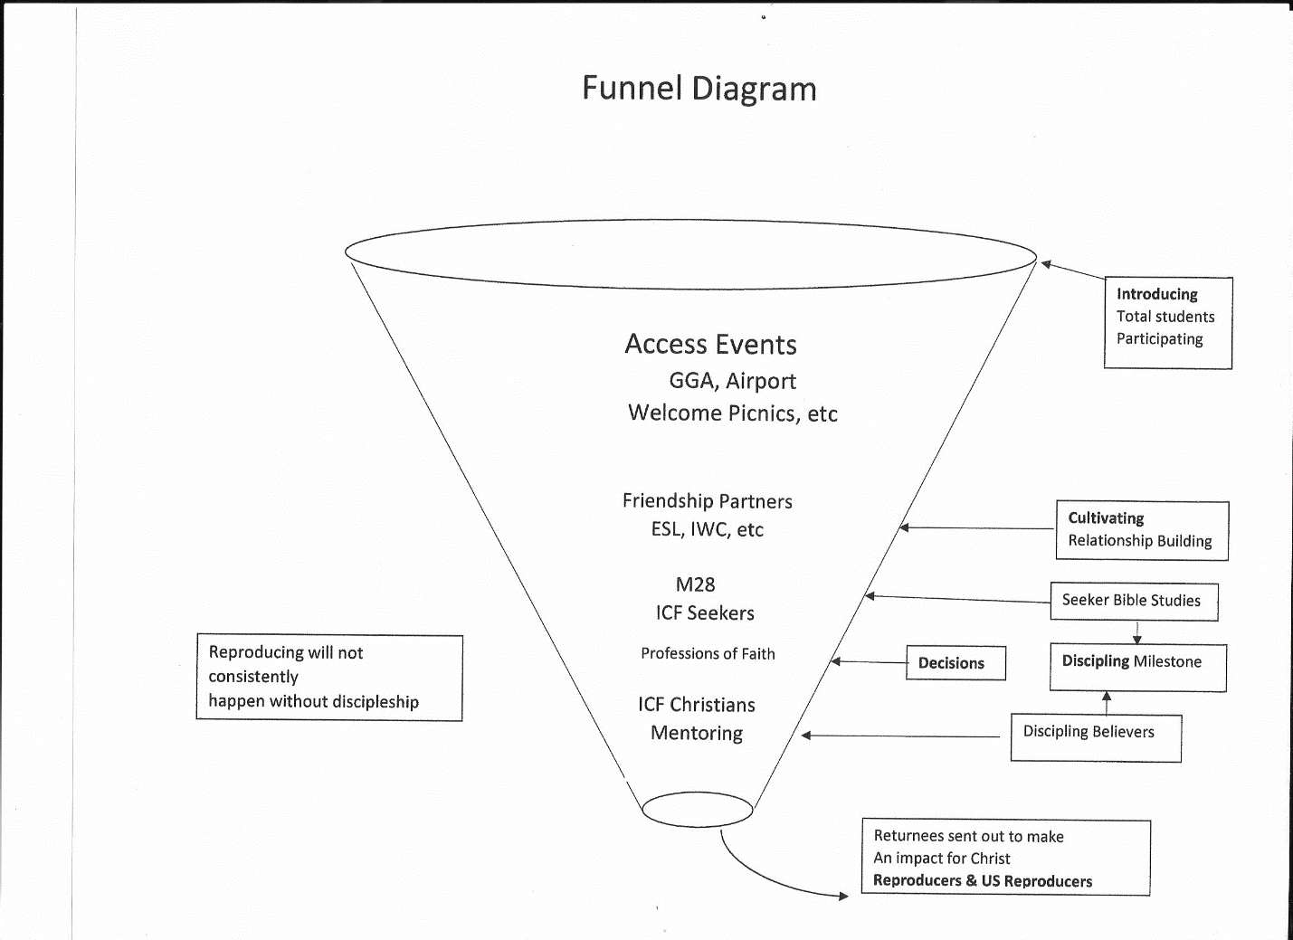

ABBREVIATIONS KEY:
GGA--Garage Giveaway ESL--English as a Second Language IWC--Intl. Women’s Connection M28--M28 Global Discipleship ICF--Intl. Christian Students Fellowship

Overview of Returnee Impact Ministry Plan Components
- Pre-return aspect (i.e., Re-entry prep)
- Compile a list of re-entry resources [Show on www.isireturneeconnections.org (PW-protected) and have sample books: New Horizons, Returning to China, Think Home]
- Develop networks by country of Christian students while still in the US. This will feed into the returnee networks once they return home.
- Develop a structured internship/training program for international seminary students during OPT year.
- Connecting returning students to Christians in their home countries.
- Expand current returnee connections database to compile (double entries by end of 2022) and promote its use among staff.
- Develop a list of ISI staff with strong networks in various countries. These staff can be a resource to staff sending returnees back to those countries.
- Develop returnee networks (next) that returning students can be connected to.
- Establish returnee networks in key countries/groupings of countries.
- Equip staff in personal follow-up (online, personal visits, & retreats)
- “Over and above” initiatives of individual staff (e.g., Solomon Kendagor, Kimberly Carlson)

What can you do as a staff person to promote greater returnee impact?
- Prepare your Christian students before their return home
- Regular discipleship & service opportunities
- Helping them discover giftedness or gain a vision for future ministry
- Specific Bible studies or conversations to prepare for return (e.g., re-entry resources).
- Encourage them to go to Equippers Conference (Japan) or Thrive Retreat (China)
- World Changers Conference.
- Help them get connected when they return home
- Utilize returnee connections database, also ISI Grapevine (To subscribe email Team@isionline.org)
- Utilize other networks, such as ACMI.
- Follow-up after they return home
- Continued online discipleship after their return
- We want them to get connected with church and Christians in their country, but that is not always easy and many slip through the cracks.
- The ISI staff can be a spiritual lifeline in the transitional period by having Bible study or doing mentoring online with the student for a while.
- God’s Story and M28 Global Discipleship mobile apps are key resources that can be used by staff with returnees, but also returnees with others.
- What about China?
- Staying connected on social media
- Find the right platform: WeChat (China); WhatsApp (India, Pakistan), Line (Singapore, Taiwan), etc. Zoom for Bible studies or meetings works for all. Signal. Facebook (not in China).
- Security concerns: Encourage them to get a VPN. Avoid spiritual content on WeChat.
- Consider making check-in appointments with some returnees to chat and see how they are doing (Zoom or other platform).
- Returnee trips
- I haven’t been able to take trips during COVID, and it’s not advisable into China due to increasing surveillance but, when possible, these can be very effective.
- I have taken trips in multiple years (2004, 2008, 2011, 2015, 2017, 2019) and have been to many countries (China 5x, Japan 3x, Taiwan 3x, and 5 others—India, Singapore, Indonesia, Thailand, Korea).
- You can be introduced to family and friends, have further conversations to encourage believers & see how they are doing spiritually, and to sow seeds of witness for non-believers.
- Returnee reunions allow you to meet a larger group at once and to invite local Christians that you can introduce them to. (e.g., Kimberly in Japan).
- Returnee retreats can help maximize the spiritual impact (especially for Christian returnees).
- Avoids just doing sightseeing with students without meaningful conversations
- Discuss the challenges they are facing as a Christian and how to deal with them
- Include Bible/spiritual component to give them a spiritual “shot in the arm”
- Include time to pray and share with one another
- Provides a chance to network with other Christian returnees.
- Use TRI* as a tracking tool for reproducers
- Currently in stats, we report reproducers once in a lifetime. This gives the unintended message that you have no further responsibility with following them up.
- The TRI (*Total Reproducing Impact) tool requires ongoing tracking (every 2 years). Every time you report a reproducer, you put them on a reproducer list and assign a level 1, 2 or 5 and include a short description of why they are a reproducer.
- Level 1—A returnee who has done one or more of the following during the last two years:
- Led (or played a key role in leading) someone to Christ.
- Discipled or mentored at least one believer.
- Involved in serving in a church, Christian ministry, or personal outreach
- Level 2—A returnee who has done one or more of the following during the last two years:
- Led (or had a significant role in leading) at least five people to Christ
- Discipled or mentored at least three believers
- If using M28…Has led an M28 Study and coached one or more M28 groups growing out of an M28 group that the returnee started
- In vocational Christian ministry of some sort
- Served on the elder board (or equivalent) of his/her church or on the board of a Christian organization
- Is supporting Christian ministry financially at a significantly high level.
- Level 5—A world impact maker, a returnee who has done one or more of the following (and is continuing in active and fruitful ministry):
- Has led at least 100 people to Christ (in his/her lifetime, with a continuing fruitful evangelistic ministry)
- Has discipled or mentored at least five people who can now be considered Level 2 or Level 5 reproducers
- Using the M28 model, has initiated and overseen many levels of multiplication of M28 groups in a way that has impacted the lives of hundreds
- Is the CEO/President or other high-level leader (VP or high-level director) in a large Christian ministry
- Is the Senior Pastor of a large church that is making a world impact through significant disciple-making ministry and/or worldwide global missions outreach
- Is Board Chair of a large Christian ministry having ministry impact in multiple countries
- Is supporting Christian ministry financially at a very high level and in a way that is clearly making a significant world impact for Christ.
- See Ithaca reproducers as an example.
- How using TRI helps:
- It helps you focus on the end-goal in a way that will encourage your returnee follow-up efforts and influence your ministry strategy/approach.
- TRI allows you to see the overall effectiveness of a particular ministry in producing reproducers over time. The goal is to see the TRI increase.
- You can sort the list in many ways to help analyze the data and evaluate effectiveness of ministry, such as by three-year or five-year blocks to help compare TRI of one time period with another (and if different ministry models were used, to evaluate the effectiveness of them). [I have done that this in the Northeast].

