***Teacher***

**One-on-One Conversations**

**|Book One|**



**April 2020 – English Version** **Teacher’s Introduction**

Thank you for your desire to share the Gospel through the One-on-One Conversation Partners curriculum. The goal of this curriculum is to help English as a Second Language learners with their conversational English skills, while also sharing with them the love and truth of the Gospel of Jesus Christ.

Through this program you will establish friendships which, many times, will last for the rest of your life. We welcome you to this unique Christian approach to caring for and sharing with others.

**Teacher & Student Versions of Each Lesson**

There are two versions of each One-on-One conversation partner lesson - a “Student Version” and a “Teacher’s Version.”

The only difference between the Student and Teacher versions are the notes added to the Teacher Version of “The Lesson.” These notes are designed to help teachers learn “best practices” in teaching Second Language Learners, help teachers understand some cultural differences that may impact how your student understands a particular topic, and to give suggested answers to questions that appear in each lesson.

Teacher notes will appear in **RED**. Other than the red notes, the Teacher Version is exactly the same as the Student Version.

**Preparation Time**

Please take 30-60 minutes to prepare for each lesson. You should review the questions and red teacher notes prior to meeting with your student. This will help you be more prepared to answer possible questions the student may have.

Being prepared can save you a lot of time and help you keep the lesson flow intact, thus allowing you to teach each lesson’s concepts better.

***\*Before you get started, please make sure you have gone through the One-on-One Teacher Handbook for instructions on how to use the curriculum.\****

**Table of Contents** - Teacher Version

**Lesson One – What is the Bible? 5, 3**

In this lesson, we will study some basic facts about the book Christians call the Bible.

**Lesson Two – Where Does Christianity Say We Come From? 9, 6**

In this lesson, we will study the topic of the Creation of the world from a Christian perspective.

**Lesson Three – Did a Man Named Jesus Really Exist? 13, 10**

In this lesson, we will look at the historical evidence for the existence of the man Christians call Jesus Christ.

**Lesson Four – Who Was Jesus? 17, 14**

In this lesson, we will look at who the Bible says Jesus was.

**Lesson Five – Jesus’ Parables 20, 17**

In this lesson, we will learn about Jesus’ parables and why He chose to use them in His teaching.

**Lesson Six – Our Lostness 24, 20**

In this lesson, we will study the Christian concepts of all men being “lost” and how God has made it possible for us to be “found.”

**Lesson Seven – God Our Loving Father 27, 23**

In this lesson, Jesus will introduce us to the concept of God as our loving Father who is always willing to forgive what we do wrong as long as we confess and repent of our wrongdoings.

**Lesson Eight – Zacchaeus and True Repentance 31, 27**

In this lesson, we will read about a real-life encounter between Jesus and a Jewish tax collector named Zacchaeus. Through their encounter, we will learn what true repentance looks like.

**Lesson Nine – Jesus Paid the Penalty for Our Sins 35, 30**

This lesson explains the consequences of sin in our lives, and how Jesus was the only one who could pay the penalty for our sins.

**Lesson Ten – The Day of Judgment 40, 35**

In this week’s lesson we will learn about the Christian concept of a “The Judgment Day” when all people who have ever lived will stand before God and be judged.

**Lesson Eleven – How Will God Judge Us? 43, 38**

In this lesson, we will look at how the Bible says God will judge all people.

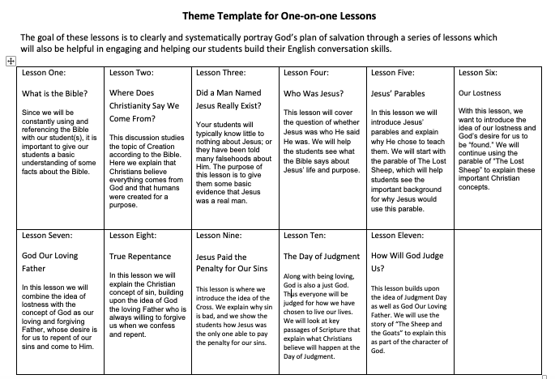

**Lesson One: What is the Bible?**

**Teacher Tune-Up**: Today we are going to study the historical and geographical background of the Bible. Many people who have not read the Bible don’t realize it is the oldest piece of consistent literature in the history of the world. Moses wrote the first 5 books of the bible in 1450 BC. By comparison, Homer wrote the Odyssey around 800 BC and Confucius first appeared in China in 500 BC. Even if your student does not believe the Bible is from God, they will find it to be a fascinating, historical book!

***Reading Aloud with Your Student****:* You should always have your student read the lesson out loud. This will be a good opportunity for you to help your student with their pronunciation of words. It is always good to seek permission to “correct” someone’s English when starting to study with them. Having “permission” removes any awkwardness or doubt about what will be going on during the lesson. It will clarify your role as a “teacher” and not simply a friend who is sharing time with them. Simply ask, “Do you want me to help you with your pronunciation of words as we are reading and speaking together?” You will find your student will always answer “yes.” This may seem like a little thing, but it will help quickly establish your intentions and allow you both to immediately feel comfortable during the process of helping them with their pronunciation.

**Vocabulary**

* BC
* AD
* Collection
* Testament
* Greek
* Hebrew
* Latin
* Covenant
* Strange
* Foreign
* Geographic
* Chapters
* Verses
* Accurate
* Fictional
* Myths
* Fairy Tales
* Ancient
* Historical Accuracy
* Middle-East

**What is “The Bible?” -** The Bible is not one book. The Bible is actually

**a collection** of books written by 40 different authors between the years 1450 BC and 95 AD. The word “Bible” comes to us from the Greek word *biblios* which means *books* or *scrolls*（.

**Old Testament/New Testament-** The books of the Bible are divided into two main sections or groups:

*Old Testament:* Thirty-nine books written between 1450 BC and 450 BC dealing mainly with the creation of the world and the history of the Jewish people’s interaction with God.

*New Testament*: Twenty-seven books (or letters) written between 35 AD and 100 AD dealing with Jesus’ life and the early years of Christianity.

The Old Testament was written in the Hebrew language, and the New Testament was written in Greek. *Teacher – Open a Bible and show student the Old and New Testament.*

**What does the word Testament mean?  -**The word “Testament” comes from the Latin word “*testamentum.”* This word means *“a covenant,”* which is similar to the English word “*contract*,” but a ***covenant*** is typically more meaningful and stronger than a contract.

A **covenant** is an agreement between two parties:

“If you will do __________, then I will do _____________.

An example of a covenant today is a marriage.

**Question:** Who are the Old Testament and the New Testament covenants between?

*OT – God and the Jewish people (promised land, make into a great notions, the world will be saved through them, if they follow God)*

*NT – God and all people (salvation from our sins, if we accept what Christ has done for us)*

**Question:** Why do we use the word “covenant” when talking about the Bible instead of “contract?”

**Names of the Books of the Bible**  **-**  Many of the names of the Books in the Bible seem strange and foreign. That is because they are foreign! They are words translated into our language from the Hebrew and Greek languages, sometimes directly or with minor changes.

Books in the Bible are typically named after the author, geographic areas, or information contained in the book. The name of each book will often give you valuable information about the contents of the book. Some examples:

**Teacher: Open your Bible and show student the following books.**

**Name of Book What Name Refers to**

Matthew A Jewish man who became a disciple of Jesus and traveled with him.

Galatians A book written to Christians living in the region of Galatia.

Timothy A book written by a man named Paul to a young student of his named Timothy.

1 John The first of a collection of 3 books written by a man named John (2nd John, 3rd John).

Romans A book written by a man named Paul to Christians living in the city of Rome.

**The Books of Bible Are Divided into Chapters and Verses -** The books of the Bible were originally written without chapters or verse numbers. Chapter divisions were added around 1200 AD and verse divisions were added around 1550 AD. This was done for ease of study and accurate referencing.

**Example: “Luke 3:16”** **-** When you see a Bible reference written down, the first thing written is the name of the book, then the chapter, and lastly the verse. For example, when you see “Luke 3:16” with a Bible verse, you know that this verse is the 16th verse of the 3rd chapter of the book of Luke.

Book 1st → Chapter 2nd → Verse 3rd

Exercise: Practice having your student find a book, chapter, and verse of the bible. You can give them a page number to find the beginning of a particular book, but then have them find the chapter and verse and read it.

**Beginning of the Written History of Bible -**Around 1450 BC – Moses wrote the first 5 books of Bible. These 5 books outline the Creation of the world, events leading up to the first Jewish people, and the early history of the Jewish people from 2100 BC to 1400 BC.

**Geography of the Bible**

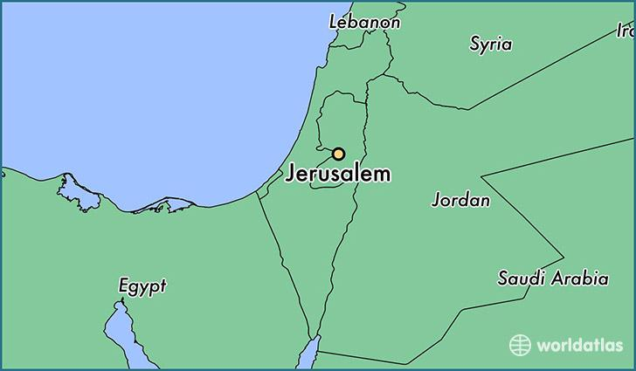

***Israel***

**Question**: What part of the world is this?

*The Middle East! Thus Christianity is a middle-eastern religion, not western. This will be a surprise to many International students who think Christianity has always been a “Western” or “American” religion.*

**Is the Bible a Collection of Myths and Fairy Tales?**

**Question:** What is a **myth**? What is a **fairy tale**? *A myth is typically thought of as a story that contains elements of truth that, over time, have become exaggerated. A fairy tale is typically a made up, fantastical story.*

*Teacher:  you can ask your students if they feel the Bible is a collection of myths or fairy tales.  You may be surprised by their answers! Many do not believe there was ever a man named Jesus Christ (fairy tale), or even if he did exist, the stories about him have become exaggerated over the years (myth).*

Many people who have not researched the Bible feel it is full of fictional people and fictional places. They are often amazed to find out that the people, and the places we see in the Bible are not fictional. Instead, all of these people and places actually did exist – or still exist even today!

**Historical Accuracy of the Bible** - The Bible has proven to be more historically and geographically accurate than any other ancient book. It has been subjected to the most detailed analysis possible, for thousands of years by thousands of people, and each time has been proven to be historically and geographically accurate.  
  
The Bible mentions hundreds of cities, kings, countries, and geographic details. Many of these places and people were lost to history for thousands of years. Yet as modern archeology has uncovered city after city in the ancient sands of the Middle-east, we have found the Bible to be 100% accurate. Even non-Christian scholars do not doubt the authenticity of the people and places in the Bible. Over the years, and even today, there are non-Christian scholars who have made the study of the Bible their life’s work.

**Question:** Why do you think it is important to understand that the Bible is historically and geographically accurate? We would expect anything from God to be error free and accurate!   
 **Next week:** Creation—Where does Christianity say we come from?

**Lesson Two: Where Does Christianity Say We Come From?**



**Vocabulary**

* Formless
* Vegetation
* Seed-bearing
* Swarm
* Scurry
* Offspring
* Livestock
* Reign

**Introduction:** Christianity teaches that everything, including humans, was created by God. Following is the story of the creation of the world from the Bible:

|  |
| --- |
| The Beginning 1 In the beginning God created the heavens and the earth. **2**The earth was formless and empty, and darkness covered the deep waters. And the Spirit of God was hovering over the surface of the waters.  **3**Then God said, “Let there be light,” and there was light. **4**And God saw that the light was good. Then he separated the light from the darkness. **5**God called the light “day” and the darkness “night.”  And evening passed and morning came, marking the first day.  **6**Then God said, “Let there be a space between the waters, to separate the waters of the heavens from the waters of the earth.” **7**And that is what happened. God made this space to separate the waters of the earth from the waters of the heavens. **8**God called the space “sky.”  And evening passed and morning came, marking the second day.  **9**Then God said, “Let the waters beneath the sky flow together into one place, so dry ground may appear.” And that is what happened. **10**God called the dry ground “land” and the waters “seas.” And God saw that it was good. **11**Then God said, “Let the land sprout with vegetation—every sort of seed-bearing plant, and trees that grow seed-bearing fruit. These seeds will then produce the kinds of plants and trees from which they came.” And that is what happened.**12**The land produced vegetation—all sorts of seed-bearing plants, and trees with seed-bearing fruit. Their seeds produced plants and trees of the same kind. And God saw that it was good.  **13**And evening passed and morning came, marking the third day.  **14**Then God said, “Let lights appear in the sky to separate the day from the night. Let them be signs to mark the seasons, days, and years. **15**Let these lights in the sky shine down on the earth.” And that is what happened. **16**God made two great lights—the larger one to govern the day, and the smaller one to govern the night. He also made the stars. **17**God set these lights in the sky to light the earth, **18**to govern the day and night, and to separate the light from the darkness. And God saw that it was good.  **19**And evening passed and morning came, marking the fourth day.  **20**Then God said, “Let the waters swarm with fish and other life. Let the skies be filled with birds of every kind.” **21**So God created great sea creatures and every living thing that scurries and swarms in the water, and every sort of bird—each producing offspring of the same kind. And God saw that it was good. **22**Then God blessed them, saying, “Be fruitful and multiply. Let the fish fill the seas, and let the birds multiply on the earth.”  **23**And evening passed and morning came, marking the fifth day.  **24**Then God said, “Let the earth produce every sort of animal, each producing offspring of the same kind—livestock, small animals that scurry along the ground, and wild animals.” And that is what happened. **25**God made all sorts of wild animals, livestock, and small animals, each able to produce offspring of the same kind. And God saw that it was good.  **26**Then God said, “Let us make human beings[[b](https://www.biblegateway.com/passage/?search=genesis+1%3A1-31&version=NLT#fen-NLT-26b)] in our image, to be like us. They will reign over the fish in the sea, the birds in the sky, the livestock, all the wild animals on the earth, and the small animals that scurry along the ground.”  **27**So God created human beings in his own image.     In the image of God he created them;     male and female he created them.  **28**Then God blessed them and said, “Be fruitful and multiply. Fill the earth and govern it. Reign over the fish in the sea, the birds in the sky, and all the animals that scurry along the ground.”  **29**Then God said, “Look! I have given you every seed-bearing plant throughout the earth and all the fruit trees for your food. **30**And I have given every green plant as food for all the wild animals, the birds in the sky, and the small animals that scurry along the ground—everything that has life.” And that is what happened.  **31**Then God looked over all he had made, and he saw that it was very good!  And evening passed and morning came, marking the sixth day.  (Genesis 1:1-31 NLT) |

**Question:** Have you ever heard this story of Creation before? What are your first impressions of it?

**Question**: Why do you think God “saw that it was very good” when he had finished creating?

In the Creation account of the Bible, God is very purposeful in how He creates the world. There is a process and order to the things He creates. God also made humans differently than the rest of the animals and plants.

**Question:** Why did God give humans “reign” over the rest of the world?

**Why did God create us?**

The Bible tells us that God made humans different from the rest of Creation. The following passages explain why God created us:

|  |
| --- |
| We are God’s creation. He created us to belong to Christ Jesus. Now we can do good works. Long ago God prepared these works for us to do.  (Ephesians 2:10) |
| So whether you eat or drink or whatever you do, do it all for the glory of God.  (1 Corinthians 10:31) |

**What are you?**

It is common to hear people from some cultures (even Americans) say, “I’m an atheist.” But are they really an atheist? Or is there confusion about what this word actually means?

The word “theo” is a Greek word that means “God.” A “theist” is someone who believes in the idea of a God. Any time you put the letter “a” in front of a word, it means “against.” So an “atheist” is someone who is *against* the idea of a God.

**Theist** = believes in a God

**Atheist** = against idea of a God

If given only these two choices of words to describe oneself, some people might have to logically choose “atheist” even though they aren’t really “against” the *idea* of a God.

There is a third word that can be used to describe someone who is not a theist, but who is also not an atheist. That word is “agnostic.” This word comes from the Greek word “agnostos” which means “unknown” or “unknowable.” Simply put, an agnostic is someone who says, “I don’t know if there is a God.” This kind of person does not claim belief or disbelief in God. The scientist Thomas Huxley first used this word in 1869 to describe his own position in regards to his belief in God.

**Agnostic** = I don’t know

A Pew Foundation study found that over 84% of the people in the world are theist, 13% are agnostic, and only 3% are actually atheist.

**Question:** Why do you think it is important to understand if you are a theist, atheist, or agnostic?

**Question:** Do you consider yourself to be a theist, atheist, or agnostic? Why?

**Is it “silly” or unscientific to believe in a God?**

Some of the greatest scientists who have ever lived (and are living) have been theist. Galileo and Albert Einstein were theist. Francis Collins, the current director of the National Institute of Health in America and the leader of the worldwide Human Genome Project is a Christian. Richard Smalley (1943-2005), who was a Nobel laureate in Chemistry and known for groundbreaking work in nanotechnology, was a Christian. Peter E. Hodgson (1928-2008) was a British physicist, who was one of the first to identify the K meson and its decay into three pions, was also a Christian…

A list of just the names of Christian scientists from around the world would fill up entire books. Science as we know it would not exist without the contributions of these Christian scientists.

**Question**: Why would a scientist claim to be a Christian?

**Teacher**: Christian scientists look at their work as “discovering” how or what God has done. They typically see the complexity of nature and the intricacy of its design as proof of a designer God. Most feel “chance” (evolution) cannot explain our origins or development.

**Next week:** We will study the question, “Did a Man Named Jesus Really Exist?”

**Lesson Three: Did a Man Named Jesus Really Exist?**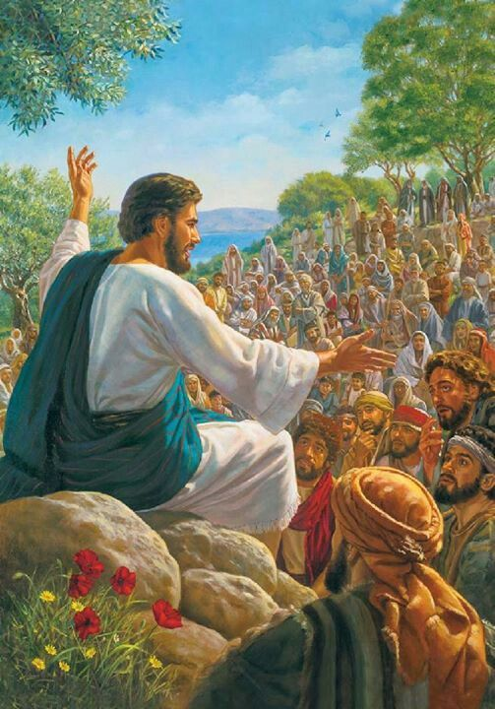

**Teacher Tune-up:** It is important that your students feel that they can talk openly with you. Part of this will be understanding where they are coming from culturally and not being surprised if they think differently than you do. For example, many Christians are surprised to find out many cultures think of Jesus as a fictional character, like a person from a Disney movie. They find the stories in the Bible to be too amazing to believe and think of them as superstitions. Do not be offended by their thoughts, instead look at their views as an opportunity to be the first to share the truth about Jesus with them.

DO NOT try to immediately change their views. Thank them for their candidness and move on to the lesson. Let the Holy Spirit work on their hearts as they learn about Jesus and read from the Bible in the coming weeks. Don’t try to change their world view in the first 60 minutes you spend with them.

**Vocabulary**

* Impact
* Debate
* Academia
* Ancient
* Wide-spread
* Contemporary
* Miracles
* Condemned
* Descent
* Crucified

**Ice Breaker:**  What do people in your home country believe about Jesus?

-  Do they believe He was a real person, or do they believe He is a fictional character?

-  Do they think He was a good man?

-  Have you heard about any of His teachings? Which ones? 

**Introduction –** Over the next several weeks, we will be studying the life and teachings of a man named Jesus. No other person has had a greater impact on world events and history than this one man, who was born into a poor family, in a small rural town in the Middle-East.

**Did a Person Named Jesus Really Exist? -** One of the first things we must decide when studying an ancient history person is, “Did this person really exist?” This question will be the focus of this week’s lesson.

Some debate has arisen in recent years about the actual existence of the man named Jesus in the Bible. The vast majority of people in academia, Christian and Non-Christian alike, do not doubt that a man named Jesus did in fact exist. However, it is still worth looking at the ancient records that prove He really did live and die as recorded in the Bible so you can feel confident that who we are studying was a real person.

*For more background on this lesson, please review the information at the following link:*

***Was Jesus a Real Person?***[**http://y-jesus.com/wwrj/1-jesus-real-person/**](http://y-jesus.com/wwrj/1-jesus-real-person/)

**What Impact Has Jesus Had on the World? -**It would be hard, if not impossible, to believe that a person who did not exist has actually shaped world events and history the way that Jesus has. The following article points out just a few of the ways Jesus has impacted the world.   

*“But what has been the impact of Jesus Christ?...*

*-   More books and articles have been written about Jesus than about any other person in history.*

*-   Many nations use his teachings as the bedrock of their governments…*

*-   His “Sermon on the Mount” established a new paradigm in ethics and morals.*

*-   Tens of Thousands of Schools, hospitals, and humanitarian works have been founded in his name. Over 100 great universities — including Harvard, Yale, Princeton, Dartmouth, Columbia, and Oxford – were begun by his followers.*

*-   The elevated role of women in Western culture traces its roots back to Jesus. Women in Jesus’ day were considered inferior and virtual nonpersons until his teaching was followed.*

*-   Slavery was abolished in Britain and America due to Jesus’ teaching that each human life is valuable.*

*Amazingly, Jesus made all of this impact as a result of just a three-year period of public ministry. When the noted author and world historian H. G. Wells was asked who has left the greatest legacy on history, he replied, “By this test Jesus stands first.”*

    (Taken From:<http://y-jesus.com/what-impact-has-jesus-had-on-the-world/>)

**Question**: Why does it matter if Jesus was a real person or not?

**Does Jesus Appear in Any Historical Books Other Than the Bible? -** Many people who do not know much about Christianity, and even some Christians, are surprised to find that statements about Jesus appear in other ancient books—not just the Bible.

**Flavius Josephus** – Flavius Josephus was a *Roman* citizen of Jewish descent who lived shortly after the death of Jesus. He was a famous historian and author who was paid by the Roman Emperor to record Roman and Jewish History. He was *not* a Christian.

In 93 AD, in his 20 volume set of books titled *Jewish Antiquities* (a history of the Jewish people), Josephus wrote this about Jesus:

*About this time there lived Jesus, a wise man, if indeed one ought to call him a man.  For he was one who performed surprising deeds and was a teacher of such people as accept the truth gladly. He won over many Jews and many of the Greeks. He was the Messiah. And when, upon the accusation of the principal men among us, Pilate had condemned him to a cross, those who had first come to love him did not cease.  He appeared to them spending a third day restored to life, for the prophets of God had foretold these things and a thousand other marvels about him.  And the tribe of the Christians, so called after him, has still to this day not disappeared.                                                                   Jewish Antiquities, 18.3.3 §63*

Josephus was a contemporary of Peter, Paul, James, and most of the other major characters in the New Testament portion of the Bible. He grew up and lived in the same area Jesus lived in shortly after Jesus’ death, during the time the New Testament portion of the Bible was being written. He would have known people who knew Jesus personally, and thus he had a very good grasp of the facts about what he was writing.

As a Jewish historian writing about Jewish history, Josephus would have written about the most important and interesting events that happened at that time. He must have felt Jesus was an important part of Jewish history since he included Jesus in his book.

In this passage from *Jewish Antiquities*, we can see that even non-Christians knew of the widespread belief that Jesus did miracles, was a wise teacher, that Pilate condemned Him to die on the cross, and people believed He was restored to life after being dead for three days.

**Question**: Why is it important to note that Josephus is a Roman citizen of Jewish descent?

This is a non-Christian’s account of who people said Jesus was. Josephus was NOT a Christian – he was a highly educated Jewish man of “the law.” Combined with his religious background, he was also a Roman citizen who would have recognized that Christianity was NOT popular among the Romans.

If anything, he would have been against the belief that Jesus was the Messiah. So why did he write the things he wrote? We are left with the conclusion that he was only reporting what people at his time said about Jesus. Josephus was born in 37AD (shortly after Jesus death), so he would have grown up during the great debates among the Jews of “who was this Jesus who was crucified”? He was a contemporary of Peter, Paul, James, and other eyewitnesses of Jesus.

**Josephus:**  Josephus actually fought for the Jewish people in wars against Rome in the 60s AD in Israel, until he was captured by the Romans and “changed” sides. For an excellent brief account of Josephus go to:  <http://sacred-texts.com/jud/josephus/>

**Tacitus:** Another famous Roman Historian named Tacitus also wrote about Jesus (in 116 AD).

*“Nero (the Roman Emperor at that time) fastened the guilt of starting the blaze (a fire that burnt down part of Rome)… on a class hated for their abominations, called Christians…   Christus (Christ), from whom the name had its origin, suffered the* ***extreme penalty*** *during the reign of Tiberius at the hands of one of our procurators, Pontius Pilate, and a most* ***mischievous superstition****…  broke out not only in Judea, the first source of the evil, but even in Rome.*

**Question**: What is “the extreme penalty?” Crucifixion

**Question**: What is the “mischievous superstition?” He came back to life!

**Question**: Why is it important to know that a non-Christian Roman historian wrote about these things? Once again, we have a non-Christian, Roman, writing in a history book the “facts” that were believed about Jesus.  Everything he writes agrees with the Biblical account thus verifying the Biblical account is accurate.  He talks about Pontius Pilate (putting Jesus in this time frame of history), agrees that Jesus was crucified, that people said He came back to life, and that His message was spread throughout the Roman world at the time.

This passage also gives an account of a group called Christians, who followed the teachings of Christ. Tacitus also explains how Jesus was sentenced to death on the cross by the Roman government at that time. The “superstition” refers to Jesus rising from the dead after three days.

In these accounts from Josephus and Tacitus, we have two well-respected, non-Christian, Roman historians verifying the major details of Jesus’ life. This is unheard of in ancient literature! Today, anyone who says that Jesus Christ was *not* a real person, a great teacher who lived during the time of Caesar Augustus and Caesar Tiberius, who was crucified by the Romans, and was believed to have come back to life after three days, has *not* studied ancient history seriously.

**Summary:** Jesus was a real person! But was Jesus the Son of God who came to earth and died for our sins so we can someday live with God in heaven? This is something each person must investigate and decide for themselves. Literally billions of people in the past 2,000 years have investigated this very question and come to believe that Jesus is in fact exactly who He said He is.

**Next week:** We will study the question, “Who was Jesus?”

**Lesson Four: Who Was Jesus?**

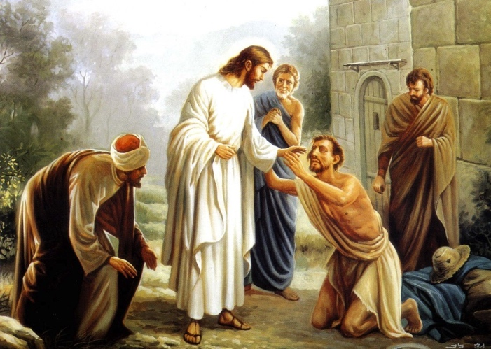

**Vocabulary**

●      Evidence

●      Title

●      Discern

●      Descriptive

●      Adjectives

●      Commandments

**Bible Vocabulary**

* Messiah: In the Old Testament of the Bible, this is a title for Jesus that also means “Savior.” God promised one day to send a **savior** *\*see “Savior” below\****.**
* Savior: A title for someone who saves others from a terrible punishment or situation. In the Bible, it means someone who saves us from our sins.
* Sin: To disobey God’s commands.
* Christ: In the Bible this title means “God’s appointed/chosen one.”
* Sacrifices: These were rituals performed by the Jewish people in order for God to forgive their sins.

**Introduction:** Last week we began the study of the man named Jesus. We addressed the historical evidence proving Jesus was a real man. This week we will answer some even more important questions--who WAS Jesus? What was His purpose? What did He accomplish?

**Why are there so Many Men Named Jesus in The Bible?**

Before we study WHO Jesus was, we first need to understand His many names. Sometimes when a person is just starting to study the Bible, it can seem confusing. There are so many people and places with so many difficult names! Sometimes people are confused about the different names we see used for Jesus:

* Jesus of Nazareth
* Jesus the Christ
* Jesus son of Mary
* Jesus son of God
* Jesus of Galilee
* Jesus the Messiah

**Question**: Why are there so many men named Jesus in the Bible? Answer: There aren’t. These are all names for the same person!

**Jesus’ Many Names** – During the time of Jesus, the majority of people in the Middle-East did not have last names (family names). They were simply known by their first name. Since many people might have the same or similar first names, *descriptive adjectives* were often added to a person’s first name to clarify exactly who was being talked about.

For example, you might have two men named John. If one John was tall and one was short, their friends might call one “Big John” and the other “Little John” to clarify which John they were talking about.

People would also use *titles* to help discern exactly who they were talking about. For example, “King John,” “John the Baptizer,” or “John the Tax Collector.”

**Question:** Following are some of the names people called Jesus during His lifetime. Which of these names are adjective phrases, and which are titles?

Jesus son of Mary     Jesus of Nazareth   Jesus the Son of God

Jesus the Christ      Jesus the Messiah   Jesus of Galilee

**Question:** Why is it important to understand the many names given to Jesus?

The names people use to describe other people help us to understand details about someone. It also helps us understand who the people at that time understood that person to be.

**Messiah and Christ:** It is important to note that people during Jesus’ lifetime called him “The Messiah” and “The Christ” because those titles mean something!

Although “Messiah” and “Christ” actually have the same basic meaning, over time (in translation) each of these words has taken on emphasis in the following ways (although the words can technically be used interchangeably).

**Messiah** = **Savior** (He will save his people)            

**Christ** = **promised or anointed one** (He was chosen and sent by God)

**Question**: If people in Jesus’ time used the words “Messiah” and “Christ” to describe Him, who did they think He was?

**More than One First Name:** To add to the confusion of names in the Bible, during Jesus’ time, many people had two different first names! For example, a Jewish man named Levi might be called Matthew by his Greek friends.

However, this shouldn’t surprise us. We still do the same thing today! International students arriving in America often adopt a new “American” name as part of their new life in America. A young man from China named Xingtao might adopt the American name of “David.” His Chinese friends will call him Xingtao, while his American friends call him David.

Don’t be surprised if you are reading the Bible and become confused by the names. The good news is, they will make sense after a little study. Over time, you will see the different names actually help you learn more and more about each Biblical character.

**Who was Jesus?**

As stated above, the Bible tells us that Jesus is the Messiah and the Savior of the world. What does this mean? The Bible tells us that all people have disobeyed God--we call this “sin.” Sin is not just “murder” or “stealing” or “lying.” Sin is disobeying any of God’s commands. Christians understand that the person called “the Messiah” or “the Savior” is the one who will save us from our sins.

**Question**: What does your culture teach about “sin?”

The Bible says that all of us have sin, thus we cannot have a relationship with God because He is perfect and without any sin.

**Question:** What happens when something that is perfect comes into contact with something that is not perfect?

In the Old Testament, God gave people commandments to follow. If they followed these commandments and made sacrifices for their sins, they people could have a relationship with God. However, NO ONE could keep all of God’s commands. NO ONE could offer enough sacrifices for their sins.

Because of this, God promised in the Old Testament to one day send a Savior. Christians believe that this Savior was Jesus, God’s only Son.

We believe Jesus came to earth, took the form of a human, lived here, was killed here, was resurrected here, and then returned to Heaven where He still is today. By dying a horrible death on the cross (crucifixion), He paid the penalty for our sins. But unlike the animal sacrifices of the past, Jesus’ death (as the Son of God) was the perfect sacrifice. No other sacrifices are now needed. We just need to accept Jesus’ sacrifice for our sins.

**Question:** What does it mean to “accept Jesus’ sacrifice?”

**Teacher**: “Accepting Jesus’ sacrifice” means we acknowledge we are sinners and that our sins are separating us from God. Since we are sinners, we cannot get rid of our own sins, and we need someone perfect to do that for us. Here’s an **analogy**: Can a person become clean using a dirty washcloth? No! It takes a clean washcloth to cleanse a person. A dirty washcloth just makes us dirtier.

Our need for a Savior (Jesus) is because we are all “lost,” or separated from God. This is a term used specifically in Christianity. We will explain this concept in more detail in the following lessons.

**Next Week:** Next week we will study the teachings of Jesus in parables.

**Lesson Five: Jesus’ Parables**

***The Parable of “The Lost Sheep”***

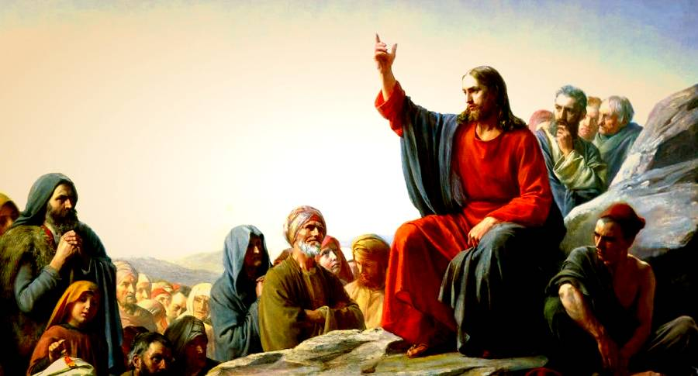

**Vocabulary**

* Parable
* Illustrate
* Moral
* Spiritual
* Illiterate
* Rejoice
* Shepherd
* Sheep
* Open country
* Joyfully
* Shoulders
* Whispering
* Source
* Income
* Ruined

**Bible Vocabulary**

* Angels: Special creatures created by God
* Repent: to recognize sin/wrongful action, ask forgiveness, and change that action
* Tax collectors: in Jesus’ time, these men worked for the government. They often took more money from the people than what they were supposed to. They were hated by everyone and seen as very dirty/sinful/bad people.
* Pharisees: A specific group of Jewish religious leaders of Jesus’ time who were expected to follow all of God’s laws
* Teachers of the Law: these were educated Jewish leaders who taught people the “Law” they believe was given by God
* Heaven: The place where Christians believe they will go when they die. It is also the place where God lives.

Teachers: Following are some questions that everyone can relate to. **Spend 5-10 minutes** asking your student to tell you about their experiences with the questions. Be ready to share an example from your own life. For example: “I once lost my credit card. I didn’t realize it until I was at the gas station trying to get gas. I was really upset when I realized it was gone. I searched my pockets, the car, the ground around the car – Nothing! So I searched everywhere again – still nothing! The more I searched the more worried and frustrated I got. Then I realized I had just used my credit card two hours before at a restaurant. So I drove back to the restaurant as fast as I could. As I was driving along, all kind of thoughts had started to run through my mind: *Did I need to call the credit card company and cancel the card? Did someone steal my card? If they did, what if the thieves were using it to buy stuff right now? How would I fix all the problems from fraudulent purchases on my credit card?* I was so relieved when I walked into the restaurant and the waiter, smiling, handed me back my card. I had left it on the table when I left the restaurant. Wow! I was so happy I gave him $20!”

**Ice Breaker:** Have you ever lost something important and then found it? Please tell about your experience(s):

**Question:** What did you lose? *Important things that people might lose: cell phone, laptop, a child in a crowd, car keys, files on the computer, money, my way when traveling, purse, wallet, credit card…*

**Question:** How did you feel when you realized you lost it? *Teacher: Do not accept one word answers like, “upset.” Ask your student to be more specific. “I was so worried = I wanted to cry, my mind couldn’t focus, I was sweating, my heart was pounding…”*

**Question:** How did you feel when you finally found (or didn’t find) what you lost? *I felt so relieved, happy, excited, I feel like a weight has been lifted off me. My whole day went better… If they have not found it, how does it make them feel when remembering the lost thing?*

**Parables** **-** Jesus often used stories to teach his students. The type of story that Jesus used to teach with is called a “parable.” A parable is a simple story used to illustrate a deeper moral or spiritual lesson.

Parables were a common tool used for teaching in many ancient cultures. For example, Aesopwas a famous Greek philosopher who often used parables to teach. Confucius was a famous Chinese philosopher who often used parables to help his students understand deeper meanings.

In ancient times, with largely illiterate audiences, or audiences without access to paper or writing instruments, parables were excellent ways to help students understand and remember what was being taught.

In His parables, Jesus uses stories about ordinary people like fishermen, landowners, and shepherds, or common items such as salt, bread, sheep, farming, etc., to teach deeper truths and meanings.

Today, even well-educated audiences still enjoy and learn from the parables of Jesus.

**For a full list of all of Jesus’ parables, go to:**  [**http://swapmeetdave.com/Bible/Parables/**](http://swapmeetdave.com/Bible/Parables/)

**The Parable of the Lost Sheep -** One of the parables Jesus used to teach us about our “Lostness” is called The Parable of the Lost Sheep.

|  |
| --- |
| The tax collectors and sinners were all gathering around to hear Jesus. **2**But the Pharisees and the teachers of the law were whispering among themselves. They said, “This man welcomes sinners and eats with them.”  **3**Then Jesus told them a story. **4**He said, “Suppose one of you has 100 sheep and loses one of them. Won’t he leave the 99 in the open country? Won’t he go and look for the one lost sheep until he finds it? **5**When he finds it, he will joyfully put it on his shoulders **6**and go home. Then he will call his friends and neighbors together. He will say, ‘Be joyful with me. I have found my lost sheep.’  **7**I tell you, it will be the same in heaven. There will be great joy when one sinner turns away from sin. Yes, there will be more joy than for 99 godly people who do not need to turn away from their sins.  (Luke 15:1-7 NIRV) |

**Question:** Who do the “man” and the “sheep” represent in this parable?

God and man.

**Question:** What do you find interesting about this parable? Stress that God (the shepherd) goes out hunting for the lost sheep! God is proactive about seeking that which has been lost. This is exactly what is happening RIGHT NOW as you are studying with your student! God is reaching out to a lost sheep.

**Question:** Why does this man call his friends and neighbors together? His joy is so great! What father or wife doesn’t want to tell everyone about a new baby? The news is too great to keep to yourself.

**Question:** What does Jesus’ story teach us about God’s love for lost people? God’s love moves God into action! He isn’t just sitting idly by while people are out wandering around lost, He is out pursuing them, trying to bring them home.

**Cultural Background of “The Lost Sheep” Parable** **–** During Jesus’ lifetime, many people raised sheep for a living. Sheep were a very important part of everyday life and a large part of the economy. Using a story about sheep to teach deeper truths would have been a very wise teaching technique.

People who raised sheep for a living were called “shepherds.” For shepherds, their sheep were their most important possessions. Sheep were often the shepherds’ only source of income.

*“Shepherds were common in the first century. A shepherd led his flock)… searching for the best grass and water. Bears, leopards, jackals and even hyenas were known to roam the hills of Palestine. The shepherd often risked his life risk his life: to protect his sheep from these dangers. Sometimes a sheep would fall down a crevice and the shepherd had to climb down and pull them to safety. It would have been common for a shepherd to carry a sheep on his shoulders…*

*A shepherd spent a great deal of time with his sheep and most likely knew each one by name. Every sheep was important and the shepherd’s goal was to keep every one of them safe.  
  
This is the kind of care that God has for mankind. He knows each of us by name. He does not want even one of us to go astray (go astray). Mankind had gone astray and God sent his son, Jesus, to find us.”*

*Source*: <https://missionbibleclass.org/1b0-new-testament/new-testament-part-1/parables-teachings-of-jesus/the-lost-sheep/>

**Question**: Why do you think a shepherd would risk their life for a sheep?

**Question**: Why do you think Jesus would use sheep to illustrate our lostness? Teacher: Sheep are weak (but don’t know it), sheep want to go their own way, sheep don’t recognize danger well, sheep follow their stomach instead of thinking, sheep get lost easily, sheep are rebellious, sheep need a shepherd but don’t want to follow a shepherd…

**Next Week:** We will continue looking at the story of “The Lost Sheep” and discuss what it means to be “lost.”

**Lesson Six: Our Lostness**

***The Parable of “The Lost Sheep”***

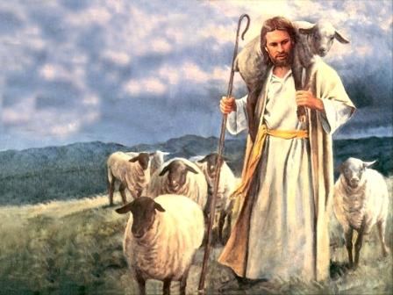

**Bible Vocabulary**

* Lostness: To Christians, this is the spiritual state of all people who do not have a relationship with God through Jesus Christ.
* Saved: **This is a term for someone who has** **a relationship with God through Jesus Christ. They are “saved” from their sins.**
* Sinners: **People who disobey God’s commands**.

Last week we started studying the parable of the Lost Sheep. Let’s continue our study of this parable today:

**The Parable of the Lost Sheep:**

|  |
| --- |
| The tax collectors and sinners were all gathering around to hear Jesus. **2**But the Pharisees and the teachers of the law were whispering among themselves. They said, “This man welcomes sinners and eats with them.”  **3**Then Jesus told them a story. **4**He said, “Suppose one of you has 100 sheep and loses one of them. Won’t he leave the 99 in the open country? Won’t he go and look for the one lost sheep until he finds it? **5**When he finds it, he will joyfully put it on his shoulders **6**and go home. Then he will call his friends and neighbors together. He will say, ‘Be joyful with me. I have found my lost sheep.’  **7**I tell you, it will be the same in heaven. There will be great joy when one sinner turns away from sin. Yes, there will be more joy than for 99 godly people who do not need to turn away from their sins.  **(Luke 15:1-7 NIRV)** |

**Lostness:** In the parable of the Lost Sheep, we are introduced to the Christian concept of being “lost.” “Lost” is an interesting word. The literal definition of the word “lost” is, “not knowing where you are.” Christianity uses this term to describe people who do not have a relationship with God: They are “lost” and don’t know God. This is not a moral judgment a Christian makes about another person, but only an observation of a person’s spiritual situation.

**Lost = No Relationship with God**

Christians believe that ***everyone*** is “lost” until they become “found.” For Christians, being “found” means a lost person decides they don’t want to be lost anymore, and instead they want to have a relationship with God.

**Found**

**Lost** You have a relationship with God

No Relationship with God

Another common term for “found” that Christians use is “saved.” Someone who is saved has been “found” and has a relationship with God. They are no longer “lost.”

**Found**

**Lost** You have a relationship with God

No Relationship with God and are **Saved from being lost**

**Why are we lost? -** Relationships are lost, ruined, or broken, when one person does something that another person cannot accept. We see this happen in the world around us every day. For example, a husband does something that ruins the relationship between him and his wife. Maybe he lied to her about something important.

Because of what he has done, he has “lost” his relationship with his wife. Now the husband must make a choice: “Do I want to ***restore*** my relationship with my wife or not?” Does the husband want to “find” the relationship again, or let the relationship remain “lost?”

**Lost** Your relationship with your wife

**Found**

No Relationship with wife is restored

The things that we do that ruin our relationship with God are called sin. The Bible tells us what actions we do that God considers sin.

In simple terms:

**Sin = Disobedience of God’s Instructions = A lost relationship with God**

**What does a person need to do to have a relationship with God?**

The Bible says there are three steps a person must take to no longer be lost:

**First**: You must first understand and admit that there are things that you have done, and are doing (sins), that are ruining your relationship with God. **ADMIT**

**Second**: You need to ask for forgiveness for what you are doing, or have done, that has ruined your relationship with God. **CONFESS**

**Third**: You need to stop doing whatever it is (sin) that is ruining your relationship with God. **REPENT**

**Admit 🡪 Confess 🡪 Repent**

**Are You a Sinner (Lost)?** - People are sometimes offended when they are told “you are a sinner.” But the reality is that *everyone* is a sinner! We all do things God has told us we should not do. The Bible says:

*All of us are like sheep. We have wandered away from God. All of us have turned to our own way. (Isaiah 53:6 NLT)*

God is very specific about the things that ruin a relationship with Him. He calls these things “sin.” God is also very specific about what a person must do to remove the sins that are ruining our relationship with Him. The Bible says that we must ask for God’s forgiveness.

Christians believe all people, Christians and non-Christians, do things every day that can potentially ruin our relationship with God.

Without understanding what sin is and asking God for forgiveness, we will remain in our state of “lostness.”

**Question**: According to Christianity, are you currently “lost” or “saved”?

**Next Week:** We will learn about “God Our Loving Father” who always desires to forgive us.

**Lesson Seven: God Our Loving Father**

***The Parable of “The Lost Son”***

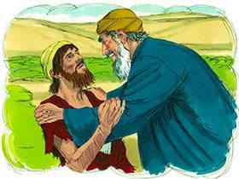

**Vocabulary**

* young
* foolish
* embarrassed
* hurt
* react
* inheritance
* extravagant
* continue
* share
* family property
* divide
* waste
* wild living
* stomach
* fit
* tender
* robe
* sandals
* calf
* feast
* celebrate
* hired servant

**Bible Vocabulary**

* Sinned: When someone has disobeyed God’s commands
* Forgiveness: When you say someone no longer owes you the debt that they owed you.

**Teacher Tune-Up:** We should always try to be prepared to answer questions, but it is impossible to be prepared for every question. You should become comfortable with NOT being the “Bible Answer Man/Woman.” You should always be willing to say, “That is a really good question. Let me research it a little more before I try to give you an answer.”

Then, *write down their question*. This shows your student that you really do care about their question. It is also the best way to remind yourself what the question is later. ☺

**Ice Breaker:** When you were young, did you ever do something foolish that embarrassed or hurt your parents?

**Question**: How did your parents react to your foolishness?

**Question**: How did you “fix” the problem(s) you created by your foolish actions?

Your student may not have a story or may not want to share. Please be ready to share your own story of something you did that was foolish that hurt your parents. This may make them feel more comfortable with sharing. If not, you will hopefully have made the point through your own story, so move on to “Intro.”

**Introduction:** Last week we studied the Christian concept of being “lost.” This week we are going to share another story about something that is lost, but this week it is a *person* who is lost, not a sheep!

**Background of “The Lost Son” Parable -** Another well-known title for this parable is “The Story of the Prodigal Son.” The word “prodigal” means “amazingly wasteful.” This is a very good description of how the young man lives once he takes his inheritance from his father and leaves. Once he moves away, he lives an extravagant and wasteful lifestyle.

Leaving an inheritance to your children was an important custom in Jesus’ time. According to Jewish customs, children were expected to respect their father as the owner of all of their inheritance until he died. In this story, the “lost son” does just the opposite. He demands his inheritance *before* his father dies!

Dr. Brad Young, Ph.D, tells us more about the background of this parable and the Jewish custom of inheritance:

*“What did the father think when his younger son asked for his inheritance before his (the father’s) death? In reality, the younger son asked his father to die. This is clear from the Jewish laws of inheritance... The original Jewish audience asks how a son can be so cruel as to ask for the inheritance before the father dies. Money is more important to the younger boy than is his relationship with his father.”*

To read more of Dr. Young’s article about the Lost Son, go to: <http://www.gospelresearch.org/ProdigalSon.html>

**Question**: Why do you think the son wanted to leave his father?

In the following story, Jesus introduces us to the concept of God as our loving Father, who is always willing to forgive what we do wrong as long as we confess our wrongdoings and repent of doing them.

**The story we will study this week:**

|  |
| --- |
| **The Story of the Lost Son** 11 Jesus continued, “There was a man who had two sons. 12 The younger son spoke to his father. He said, ‘Father, give me my share of the family property.’ So the father divided his property between his two sons.  13 “Not long after that, the younger son packed up all he had. Then he left for a country far away. There he wasted his money on wild living. 14 He spent everything he had. Then the whole country ran low on food. So the son didn’t have what he needed. 15 He went to work for someone who lived in that country. That person sent the son to the fields to feed the pigs. 16 The son wanted to fill his stomach with the food the pigs were eating. But no one gave him anything.  17 “Then he began to think clearly again. He said, ‘How many of my father’s hired servants have more than enough food! But here I am dying from hunger! 18 I will get up and go back to my father. I will say to him, “Father, I have sinned against heaven. And I have sinned against you. 19 I am no longer fit to be called your son. Make me like one of your hired servants.”  20 So he got up and went to his father.  “While the son was still a long way off, his father saw him. He was filled with tender love for his son. He ran to him. He threw his arms around him and kissed him.  21 “The son said to him, ‘Father, I have sinned against heaven and against you. I am no longer fit to be called your son.’  22 “But the father said to his servants, ‘Quick! Bring the best robe and put it on him. Put a ring on his finger and sandals on his feet. 23 Bring the fattest calf and kill it. Let’s have a feast and celebrate. 24 This son of mine was dead. And now he is alive again. He was lost. And now he is found.’ So they began to celebrate.  **(Luke 15:11-24 NIRV)** |

**Question**: Is this how your parents would welcome you back if you wasted an inheritance they gave you?

**Question:** What is more valuable to the Father—the things the son has wasted or the son himself?

**Question**: Why do you think the Father forgives the son? Love

**Understanding the Story of the Lost Son**

2. The son’s way of living causes him great hardship and he loses everything his Father gave him.

1. The son wants to start living his own life, so he leaves his Father’s house, goes out on his own, and starts living the way he wants to live.

4. The son returns home, confesses his foolishness, and asks for forgiveness. The loving Father forgives him and takes him back to live with him.

3. The son realizes how foolish he has been. He now sees that he was better off living with his Father and obeying Him.

**Question**: What causes the son to finally see his own foolishness?

The hardships he experiences due to his own foolishness! If you have time, this might be a good opportunity to talk about how times of hardship or trials might actually be opportunities to grow closer to God. The difficult times allow us to see our foolishness and recognize God’s wisdom. This is what Christians mean that sometimes our problems in life are blessings in disguise!

**Steps Leading to the Father’s Forgiveness -** In the following flow chart, we see what true repentance leading to forgiveness looks like:

Teachers: Please do NOT use the following schematic to try and ***convert*** your student UNLESS you feel the Holy Spirit is moving in your student’s heart. They do not understand major concepts of Christianity yet, so any “conversion” could be false, uninformed, or just an attempt by your student to make you happy.

We will more clearly develop the idea of sin and will have ample opportunity to present the Gospel to them in later lessons. Today we are simply helping them build up an understanding of key Christian concepts.

As you go through the boxes below, please make sure you go back and read the verses noted in the boxes, taking time to make sure your student understands each step clearly.



The son clearly sees his foolishness:

Verse 17

The son confesses his sin:

Verse 21

The Father forgives the son:

Verses 22-24

The son has a repentant heart:

Verse 18-19

**You and I are the Lost Son -** As much as we hate to admit it, you and I are just like the lost son in many ways. After recognizing our foolishness, we must make a decision:

Admit our foolishness, ask God for forgiveness, start living the way He wants us to live

We think we know what is best for us, so we ignore God’s instruction and live the way we want to live.

We cause ourselves and those around us great hardship and loss.

**2 Choices**

Continue in our foolishness, continue to cause hardships for ourselves and others

**Question**: Do you think your parents would forgive you for doing something foolish if you refused to repent? This is a great place to talk about the difference between “I’m sorry” and true repentance. A person can be truly “sorry” without changing their actions or attitudes. This is actually what most people do. To repent actually means to change what you are doing so that you will not repeat your foolishness. So in the case of the question above, if you cause your parents to stay up all night waiting for you to come home, you are sorry you caused them so much worry – but then you do it again next week, this is not true repentance.

**Question:** Why do you think we continue to do things in our lives that bring us and those around us pain and suffering? Why do we not repent and change how we behave? (think of arguing with your parents or children continually, or a lab mate who you are having problems with) The most obvious answer is we are selfish and there is something we want bad enough that we are willing to continue to hurt ourselves and others to get it. Other reasons: We are so proud that we think we MUST be right, we might think we can make things turn out differently the next time, we really just don’t care if we hurt others – that is their problem.

**Question**: Since God is “all powerful,” why do you think He doesn’t destroy us when we don’t repent and keep sinning against Him? Because He loves us and knows that if we will just turn to Him for help, He can change our hearts and change our lives. This shows another one of God’s great characteristics – Patience!! (born out of His love for us). That is why He is always standing there waiting for us like the Lost son’s father – willing to forgive us and welcome us into His care.

**Next Week:** We will learn more about the Christian concept of “sin” and why it destroys our relationship with God.

**Lesson Eight: Zacchaeus and True Repentance**

***The Story of Zacchaeus***

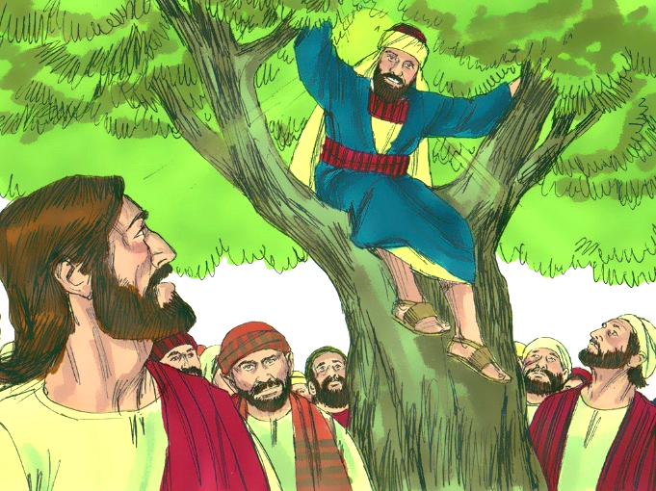

**Vocabulary**

* Zacchaeus (Za-’Kee-Us)
* sycamore-fig tree
* excitement
* displeased
* notorious
* grumble
* cheat

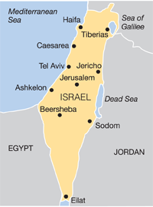

**Bible Vocabulary**

* Jericho**:** a city near Jerusalem.
* Chief tax collector: in Jesus’ time (27AD), tax collectors worked for the Roman government. Many tax collectors took more money from the people than what the people owed. Most people hated the tax collectors and thought they were very dirty/sinful/bad people. “Chief” means “leader,” so Zacchaeus would have been a very important and powerful tax collector in charge of other tax collectors.
* Salvation: To a Christian, this word means forgiveness of sins, or “to be saved from your sins.”
* Son(s) of Abraham: Jewish people were called “Sons of Abraham” because a man named Abraham was the first Jewish person. They believed they were God’s “chosen people.”
* Son of Man: Another name used in the Bible to describe Jesus.
* Lost: Christians use this term to describe anyone who is a sinner – they are separated from God
* Righteous: A person who lives the “right way,” a person who lives the way God asks us to live.

**Introduction:** Last week we read the parable about “The Lost Son” and the loving Father. This son wasted everything his Father had given him. When the son came back to his father and repented of what he had done, his loving Father gladly forgave him and took him back into His home.

This week we are going to read a real life story of a man named Zacchaeus, a tax collector and “notorious sinner.” When Jesus meets him, Zacchaeus is living a very sinful life. Rather than confronting Zacchaeus about his sinful life, Jesus instead goes to his house for dinner! During this dinner Zacchaeus decides he is going to stop living a sinful life and chooses to obey God instead.

**Question**: How do we usually treat people who are hurting us or those we love?

Teacher: The tax collectors hurt Jesus’ family, friends and neighbors by taking too much money from them. But instead of lashing out at Zacchaeus, Jesus goes to his house for dinner. Jesus cared more about Zacchaeus and his soul then about taking the opportunity to verbally abuse him.

**Background of the story of Zacchaeus (From Harold Martin)**

*“Jericho was a prosperous trade city... A considerable amount of traffic passed through Jericho. One of the principal custom houses in the Roman Empire was located there, and a man named Zacchaeus was the ‘chief’ of tax collectors in the city (verse 2). The term ‘chief among the publicans’ means that Zacchaeus presided over other tax gatherers, and received their collections, which were then transmitted to the Roman government. Tax collectors were not liked by the people in any community.*

**The Story we will Study this Week:**

|  |
| --- |
| Jesus entered Jericho and made his way through the town. **2**There was a man there named Zacchaeus. He was the chief tax collector in the region, and he had become very rich. **3**He tried to get a look at Jesus, but he was too short to see over the crowd. **4**So he ran ahead and climbed a sycamore-fig tree beside the road, for Jesus was going to pass that way.  **5**When Jesus came by, he looked up at Zacchaeus and called him by name. “Zacchaeus!” he said. “Quick, come down! I must be a guest in your home today.”  **6**Zacchaeus quickly climbed down and took Jesus to his house in great excitement and joy. **7**But the people were displeased. “He (Jesus) has gone to be the guest of a notorious sinner,” they grumbled.  **8**Meanwhile, Zacchaeus stood before Jesus and said, “I will give half my wealth to the poor, Lord, and if I have cheated people on their taxes, I will give them back four times as much!”  **9**Jesus responded, “Salvation has come to this home today, for this man has shown himself to be a true son of Abraham. **10**For the Son of Man (Jesus)came to seek and save those who are lost.”    (Luke 19:1-10 NLT) |

**Question**: Why would tax collectors charge more than they needed to? Do you think this is wrong? Why?

**Question**: Why would a man like Zacchaeus want to see Jesus?

**Question**: Why do you think Jesus choose to go to Zacchaeus’ house for dinner instead of confronting him on the street about his sinful life?

*Teacher: It is the loving thing to do. God loves us and desires our repentance from sins more than He desires the satisfaction of confrontation and proving He is right. It is like the Loving Father from last week who treasured His son more than He treasured His possessions that the son wasted.*

**Question**: Do you see any comparisons between how Jesus treats Zacchaeus and how the loving Father treated the Prodigal son in last week’s lesson?

**Question**: Why did Jesus say He came to earth? (vs 10)

Seek and save the lost – US! Jesus came to seek and save Zacchaeus, so Jesus goes to Zacchaeus’ house on purpose! Just like the shepherd went out searching for the one lost sheep. This is God, in real life, seeking out the lost and inviting them to repent.

**Question**: Do you think Jesus is seeking (searching for) you?

*Yes! What is going on right NOW? Your student is learning about Jesus. Does your student see your study with them as something God has arranged, or just a chance meeting? Ask: If God were searching for you, how would it look different than what we are doing right now – studying God’s words?*

**Zacchaeus Confesses His Sin and Repents**

Just like the Lost Son in last week’s lesson, Zacchaeus recognizes his sin, confesses his sin, and repents of his sin. Thus, Zacchaeus’ relationship with God is restored:

Zacchaeus meets Jesus – Vs 5

Relationship with God is restored – Vs 9

He confesses his sin – Vs 8

He repents of his sin – Vs 8

This is the pattern we see repeated over and over in the teachings of Jesus. This is also how we can restore our relationship with God – we must repent and get rid of the sin in our lives.

**You and I are the Lost Son and Zacchaeus -** As much as we hate to admit it, you and I are just like the lost son and Zacchaeus in many ways. And, just like them, after recognizing our foolishness and sin, we must make a decision:



Admit our foolishness, ask God for forgiveness, start living the way He wants us to live

We think we know what is best for us, so we ignore God’s instruction and live the way we want to live.

We cause ourselves and those around us great hardship and loss.



**2 Choices**



Continue in our foolishness, continue to cause hardships for ourselves and others

**The Good News -** From the stories of the Lost Son and Zacchaeus, we see that God loves us and is very willing to forgive our sins if we will come to Him and truly repent. This is actually what God wants most! It is the reason Jesus came to earth and lived with us – so He can save those who are lost.

**Next Week**: We will answer the question, “How do we get rid of our sins?” by looking at what Jesus did for us.

**Lesson Nine: Jesus Paid the Penalty for Our Sins**

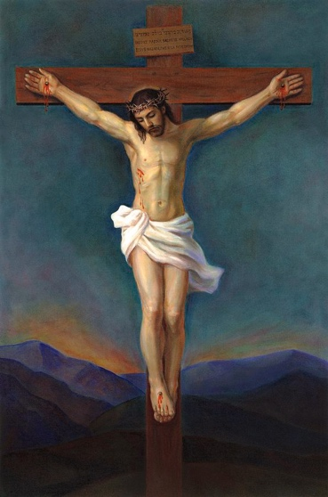

**Vocabulary**

* Disobey
* Sterile
* Equipment
* Contaminating
* Penalty

**Bible Vocabulary**

* Creation: The Bible says that the entire universe was created by God. “Creation” refers to everything that God created.
* Holy:The word “holy” means “something that is different, unique, or set apart” from everything else.

**Introduction: What is sin?**

The Christian concept of sin is actually very simple to understand: Sin is when we disobey or “go against” the will of God. Another way to say this is, when you “go against” the will of God, you are “breaking God’s laws or commands.”

**Question**: From two weeks ago, how do you think the Lost Son sinned against (went against the will of) his father? (remember sin = disobedience or going against the will of God)

**Answer**: Took his inheritance before the Father was dead, wasted his inheritance on wild living – lived in a way that was displeasing, wasteful, harmful, and did not help anyone. Pleasure driven!

**Question**: In last week’s lesson, how was Zacchaeus sinning against (going against the will of) God?

**Answer**: He was cheating and stealing from people by collecting too much tax and keeping the extra for himself. He was being greedy, selfish, lying, cheating, stealing, deceiving…

**Why Is Sin Bad?**

**- Sin is bad because it hurts us and those around us.**

**Question**: Can you think of something that you consider is a sin that is good for you or those around you?

No! This is a great way to show that even non-Christians can agree that sin is bad – lying, cheating, stealing, anger, hate, drunkenness, envy… If your student doesn’t understand the question, MAKE A LIST OF SOME OF THE THINGS GOD CALLS SIN and then talk about the result of the sins listed…

**- Sin is bad because it destroys our relationship with God.**

Christians believe that God is our Creator. Christians further believe that God loves and cares for us, His creation. He hates anything that hurts His creation.

As we noted in the question above, sin hurts us and those around us. So when we sin, we are hurting or destroying God’s creation—the creation that He loves.

**Question**: What would you think about someone who hurt or destroyed something you created and love?

**Question**: Can you have a loving relationship with someone who is destroying what you love?

**- Sin is bad because it ruins our relationship with God and separates us from Him**

God is perfect and unable to do wrong. Everything He does and everything He asks us to do is perfect and righteous (the right way). Christians believe only God is perfect. That is one reason why we call God “Holy God.” The word “holy” means “something that is different, unique, or set apart” from anyone or anything else.

**HOLY = UNIQUE, DIFFERENT, SET APART**

Teacher: Please take time to explain the phrase “set-apart”….

**Question**: If God is completely perfect, do you think this makes Him different from all other people or things?

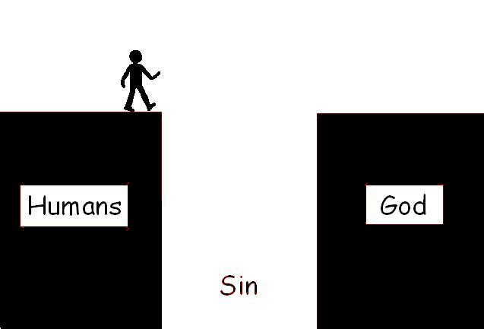Since God is the only perfect being in all of creation, He is “holy.” Our imperfections, or sins (disobedience/wrong choices), are contrary to the perfection of God and make us unable to be in His presence or have a relationship with Him. Christians say, “Our sins separate us from God.”

**Two Examples to Help Understand How and Why Our Sins Separate Us from God:**

1) In a hospital operating room, everything has been made perfectly sterile (germ free). The doctors, nurses, and all the equipment have been sterilized so that there are no germs in the operating room. Now, picture yourself walking into this operating room without having been sterilized. What would the doctors and nurses say to you? “Get out!” “You don’t belong here!” “You are contaminating everything!”

This is how it is when people with unrepentant sin try to walk into the presence of Holy God! God is perfect, or “clean,” and we are imperfect, or “dirty” (we are contaminated by our sins). We cannot possibly be allowed into the presence of God contaminated with our sins because He is perfect. Our sins make it impossible to have a relationship with God.

2) If you add dirty water to clean water, is the clean water clean anymore? No, because when clean is mixed with unclean, it all becomes unclean!

**The Good News -** From the stories of the Lost Son and Zacchaeus, we learn how much God loves us and how very willing He is to forgive our sins if we will come to Him and truly repent.

When we repent, God removes our sins which are keeping us separated from Him. We can then have a loving relationship with God. This is what God wants most – to restore our relationship with Him. But how can we have our sins removed - gotten rid of?

**Christians believe only Jesus can remove our sins and restore our relationship with God.**

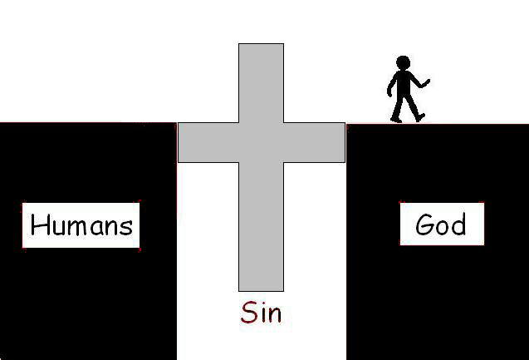

|  |
| --- |
| There is one God and one Mediator who can reconcile God and humanity—the man Christ Jesus.He gave his life to purchase freedom for everyone.  (1 Timothy 2:5-6 NLT) |

**The Cross and Payment for our Sins**

Most people would agree that, anytime a law is broken in any society, there is a penalty that must be paid by the law breaker.

Teacher: Ask your student if they agree with this statement. What is the penalty for speeding in your car, killing another person… etc.? Should we not penalize people who break the law?

Earlier in this lesson we learned that sin is equal to breaking God’s laws:

**Sin = Disobeying or “Breaking God’s Laws”**

Just like if someone breaks a law in our society a penalty must be paid, any time we break one of God’s laws a penalty must also be paid.

**Sin = Disobeying or “Breaking God’s Laws” 🡪 Penalty Must be Paid**

As we saw earlier, the penalty for our sins is “separation from God.” Christians also call this penalty “spiritual death,” since we are “spiritually” separated from God by our sins.

**Penalty Must be Paid 🡪 The Penalty: Separation from God (Spiritual Death)**

|  |
| --- |
| Once you were dead because of your disobedience and your many sins.  (Ephesians 2:1) |

Of course this doesn’t mean physically dead (although it could) – so what kind of “dead” is Timothy talking about? This may be a good place to emphasize that, because of God’s perfectness, He cannot and will not ignore sin. There is ALWAYS a penalty. Sin will always lead to separation from God. He treats everyone exactly the same – this is part of His perfection.

**Jesus Paid the Price (the Penalty) for Our Sins**

Since God is perfect, He cannot just ignore when a law has been broken. When a law has been broken, someone must pay a penalty for breaking the law.

So we have a dilemma: God loves us and does not want us to die (be separated from Him) by our sins, but we are sinners who have chosen to sin and now must pay the penalty.

This is what the cross of Christianity is all about – Jesus, through his suffering and death on the cross, willingly paying the penalty for our sins FOR US. Someone has to pay the penalty for our sins, and Jesus willingly did this with His life.

|  |
| --- |
| **21**For God made Christ (Jesus), who never sinned, to be the offering for our sin,so that we could be made right with God through Christ.  (2 Corinthians 5:21) |

Jesus’ death on the cross represents many things for us today.

- His death on the cross represents the way for us to have our sins forgiven and taken away.

- His death represents a way for us to restore our relationship with our loving Father in Heaven.

- His death represents the depth of the love God has for us, His creation.

**Discussion:** Please discuss the following verses from the Bible in relation to today’s lesson.

|  |
| --- |
| **17**This means that anyone who belongs to Christ has become a new person. The old life is gone; a new life has begun! **18**And all of this is a gift from God, who brought us back to himself through Christ.    (2 Corinthians 5:17-18 NLT) |

**Questions**:

* What does it mean to belong to Christ? (we accept what He has done for us)
* What does it mean that we are a new person? (our sins no longer bind us and we have a relationship with God)
* How has a new life begun? (if we just go on sinning, we are not really repentant)
* How is this a gift of God? (we cannot earn forgiveness of sins… our sins are too great and God’s perfection is unattainable for us on our own…)

**Next Week:** God is a loving God, but also a just God. Next week we will study what happens to those who do not accept God’s gift of forgiveness.

**Lesson Ten: The Day of Judgment**



**Vocabulary**

* inherit
* refuse
* kingdom
* swallowed up
* mortal
* immortal

**Bible Vocabulary**

* Angels and Archangel: creatures created by God to worship God.

**Teacher Tune-up:** This may be a very difficult lesson for some of your students. The idea that they are going to be judged by God (or anybody else for that matter) may offend or even make them angry. Who gives anyone the right to judge them – especially for eternity?

First, remind your student that you are only telling them what Christians believe will happen someday, we aren’t personally judging them. Second, explain judgment day is a key concept of Christianity. A person cannot understand other major concepts of Christianity if they do not have at least some understanding of the concept of a God who will one day judge us for what we have done.

**Ice Breaker:** If a professor offered to let you have all the correct answers to a test before you took the test (and it isn’t cheating, would you accept the answers? Why or why not?  Of course you would!

Discussion: Why are we using this question as the Ice Breaker? Because we want our students to realize God is the professor who has given us the answers to the test already. God has made it very possible for every man, woman, and child to “pass” His test. The fact that we refuse to accept the answers He gives us as the correct answers to the test says something about us, not about God! To understand this takes a person a long way towards understanding the judgment of God as being right(eous). The Judgment Day is not a surprise test. He has given you the questions and the answers ahead of time.

*14 Even Gentiles, who do not have God’s written law, show that they know his law when they instinctively obey it, even without having heard it. 15 They demonstrate that God’s law is written in their hearts, for their own conscience and thoughts either accuse them or tell them they are doing right. 16 And this is the message I proclaim—that the day is coming when God, through Christ Jesus, will judge everyone’s secret life. (Romans 2:14-16 NLT)*

**Introduction:** For the past two weeks, we have learned about how loving God is. Jesus teaches us about God’s love through the parable of a shepherd who goes out searching after His lost sheep, and then again through the parable of a loving Father who takes back his rebellious and wasteful son.

This week and next week we are going to study another key concept of Christianity – God’s judgment. Christians believe that one day, the world will end, and all the people who have ever lived will stand in front of God to be judged. Depending on that judgment, people will either spend an eternity ***with*** God in a place called heaven or an eternity ***without*** God in a place called hell.

**Background of “Judgment Day” from the Bible**

**Is There Really Going to Be A Judgment Day?** - There are many different teachings around the world about what will happen to us when we die. It is a question people have been asking and answering for thousands of years. Some believe there is no “afterlife” - that when we die, we just disappear and are gone forever.

Christianity teaches that this life is ***not*** the end for humans. Christians believe that a person’s soul will live on after we die.

**Question:** What are the common beliefs or theories about an “afterlife” have you heard about in your country or culture?

**Question**: Where do you think you will go when you die? Have you ever thought about this question?

Following are passages from the Bible that describe what Christians believe will happen after we die:

|  |
| --- |
| **We Will Receive New Spiritual Bodies** What I am saying, dear brothers and sisters, is that our physical bodies cannot inherit the Kingdom of God. These dying bodies cannot inherit what will last forever.  51 But let me reveal to you a wonderful secret. We will not all die, but we will all be transformed! 52 It will happen in a moment, in the blink of an eye, when the last trumpet is blown. For when the trumpet sounds, those who have died will be raised to live forever. And we who are living will also be transformed. 53 For our dying bodies must be transformed into bodies that will never die; our mortal bodies must be transformed into immortal bodies.  54 Then, when our dying bodies have been transformed into bodies that will never die, this Scripture will be fulfilled: “Death is swallowed up in victory. 55 O death, where is your victory?    O death, where is your sting?” 56 For sin is the sting that results in death, and the law gives sin its power. 57 But thank God! He gives us victory over sin and death through our Lord Jesus Christ.    (1 Cor 15:50-57 NLT) |
| **Jesus Will Return and Take Us to Heaven** And now, dear brothers and sisters, we want you to know what will happen to the believers who have died so you will not grieve like people who have no hope. 14 For since we believe that Jesus died and was raised to life again, we also believe that when Jesus returns, God will bring back with him the believers who have died.  15 We tell you this directly from the Lord: We who are still living when the Lord returns will not meet him ahead of those who have died. 16 For the Lord himself will come down from heaven with a commanding shout, with the voice of the archangel, and with the trumpet call of God.  First, the believers who have died will rise from their graves. Then, together with them, we who are still alive and remain on the earth will be caught up in the clouds to meet the Lord in the air. Then we will be with the Lord forever. 18 So encourage each other with these words.    (1 Thessalonians 4:13-18 NLT) |

**Question**: What does “victory over death” mean to you?

**Question**: Are you afraid of death? Why or why not?

**Question**: Is the idea of “heaven” new to you? What have you heard before?

**Not all people will go to Heaven -** Maybe the idea of heaven or some type of afterlife is not new to you. However, the Christian idea is very different than most other religions. The Bible tells us that not all people will be “made new” or will go to live with God forever.

***Teacher: Please look up this video to watch together if you have a smartphone or computer with you. You can also ask to do so on your student’s phone.***

Please watch the following video link from pastor Francis Chan about what Christians believe will happen after we die: <https://www.youtube.com/watch?v=hlNx7m1KW7Y>

**Question:** Do you believe all people are good? Why or why not?

**Question:** Do you believe all people are basically selfish and self-centered?

**Question:** Do you think it is bad or sinful to be selfish and self-centered?

**Summary**: This conversation about God’s judgment and eternity are scary to many people. But God has given us hope that we do not have to be afraid of what will happen to us once we die. We can find this hope by believing in Jesus Christ as the Savior of our souls.

**Next Week:** We will study ***how*** God will judge all people.

**Lesson Eleven: How Will God Judge Us?**

***The Parable of “The Sheep and the Goats”***

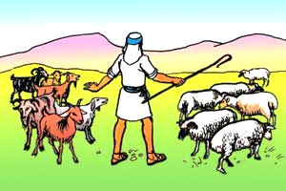

**Vocabulary**

* standards
* expectations
* obedience
* pleased
* rewarded
* glory
* throne
* inherit
* naked
* refuse
* eternal
* punishment
* blessed
* kingdom
* stunned
* reflection
* desire
* selfish
* compassionate

**Bible Vocabulary**

* Son of Man: a title given to Jesus
* Angels: creatures created by God to worship God
* Righteous: pure or holy; Christians believe being “righteous” is to follow God’s commands
* Devil: also called “Satan,” he is the enemy of God and the world
* Demons: creatures that obey the Devil
* Eternal punishment: if someone does not know God or chooses not to be saved by God, when they die they will be punished forever (eternally) in Hell
* Eternal life: if someone chooses to be saved by God, once they die on earth they will then go to live forever (eternally) with God in Heaven
* God’s Holy Spirit: God expressed as a spirit.

**Teacher Tune-up: *Warning!*** It is easy for someone to read the parable of the sheep and goats and walk away with the impression that Christianity is a works based religion: We are judged by what we did or didn’t do. It is important to note the sheep did not do their good works because they thought it was going to get them something. In fact, they clearly say, “…Lord, when did we ever see you…” The sheep did their righteous acts because they were ALREADY saved and filled with the Spirit of God. Their acts were an out-flowing of who they already were, not some plan to get themselves saved.

The goats are actually the works based group here. *“Then they will reply, ‘Lord, when did we ever see you hungry or thirsty or a stranger or naked or sick or in prison, and not help you?’”* In other words, “Lord if we knew it was actually YOU we would have helped!”

They are not willing to help nameless, faceless people because their hearts were not right; no love, compassion, kindness, gentleness, thoughtfulness of the Holy Spirit evident here. Their lack of works showed who really had control of their hearts – themselves, not the Holy Spirit.

**Ice Breaker:** What are the characteristics of a loving parent?

Think about the characteristics of a loving mother or father. Only an ***un***loving parent would allow their children to do whatever they want without any consequences. Most parents have standards and expectations for their children BECAUSE they love them! They do not want their children to waste their lives, hurt themselves, or hurt others.

It would actually be a very ***un***loving parent who does not have standards and who does not reward or punish their children according to their obedience.

**Question**: With these things in mind, how can a loving God also be a God of judgment?

It is no different with God. As our loving Father in heaven, God has standards for us and will punish or reward us according to His standards so that we might learn the right way to live and grow.

**Introduction:** Last week we learned that Christians believe that one day Jesus will return to earth, and all people will be judged by God. During this judgment, it will become clear that some people have pleased God with how they lived their lives and others have not. One group will be rewarded for their obedience while the others will be punished. Jesus uses two animals, sheep and goats, to teach us about what will happen on God’s final judgment day.

**The Story we will Study this Week:**

|  |
| --- |
| **The Final Judgment**  **31**“But when the Son of Man comes in his glory, and all the angels with him, then he will sit upon his glorious throne. **32**All the nations will be gathered in his presence, and he will separate the people as a shepherd separates the sheep from the goats. **33**He will place the sheep at his right hand and the goats at his left.  **34**“Then the King will say to those on his right (the sheep), ‘Come, you who are blessed by my Father, inherit the Kingdom prepared for you from the creation of the world. **35**For I was hungry, and you fed me. I was thirsty, and you gave me a drink. I was a stranger, and you invited me into your home. **36**I was naked, and you gave me clothing. I was sick, and you cared for me. I was in prison, and you visited me.’  **37**“Then these righteous ones will reply, ‘Lord, when did we ever see you hungry and feed you? Or thirsty and give you something to drink? **38**Or a stranger and show you hospitality? Or naked and give you clothing? **39**When did we ever see you sick or in prison and visit you?’  **40**“And the King will say, ‘I tell you the truth, when you did it to one of the least of these my brothers and sisters, you were doing it to me!’  **41**“Then the King will turn to those on the left (the goats) and say, ‘Away with you, you cursed ones, into the eternal fire prepared for the devil and his demons. **42**For I was hungry, and you didn’t feed me. I was thirsty, and you didn’t give me a drink. **43**I was a stranger, and you didn’t invite me into your home. I was naked, and you didn’t give me clothing. I was sick and in prison, and you didn’t visit me.’  **44**“Then they will reply, ‘Lord, when did we ever see you hungry or thirsty or a stranger or naked or sick or in prison, and not help you?’  **45**“And he will answer, ‘I tell you the truth, when you refused to help the least of these my brothers and sisters, you were refusing to help me.’  **46**“And they will go away into eternal punishment, but the righteous will go into eternal life.”  (Matthew 25:31-46 NLT) |

**Question**: What is the difference between the sheep and the goats?

**Question**: Do you think goats ever do good things? Yes! Everyone does good things from time to time – even bad people sometimes do what would look like good things. The question is the motivation behind what we are doing, not necessarily the actions themselves.

**Question**: Why doesn’t the King give the goats ANY credit for doing at least one good thing? Even if the goats did a good deed, it wouldn’t have mattered because they did not have the right motive behind their actions. The sheep are symbolic of people who are trying to live according to God’s desires. The goats are only living for themselves. They never worried about the sick, naked, hungry…

**Cause and Effect – The Spirit of God in Us** - The sheep are stunned when the King tells them they have been pleasing Him by the way they have helped others. They ask Him, “Lord, when did we…?”  From their reaction, we see they were not doing their good deeds in order to get something (praise from others or eternity with God), instead they were just doing what came naturally to them. Their good deeds are only a reflection of God’s Spirit already living in their hearts. The good deeds are an “out-flowing,”  or result, of the Spirit who already is living in them.

The sheep are not saved because of their good deeds, they are doing good deeds because they are already saved! When the King invites the sheep to “inherit the kingdom…” the King is actually only claiming that which is already His.

We Accept God and Submit to Him

God Changes Our Heart and Thus Changes Our Desires

Our Actions Change to Reflect Our New Hearts and New Desires

The goats on the other hand, have no desire to help others. There is no evidence of the Spirit of God living in them. Without God’s Spirit to change their hearts, they have selfish hearts that only think about themselves.

**Jesus Promises us the Gift of the Spirit of God** - So how does a person’s  heart become like the sheep’s heart?

Before Jesus died, He promised us that He would not leave us alone. He promised that, once He had died, He would send God’s Holy Spirit to live in those who love Him.

***15****“If you love me, obey my commandments.****16****And I will ask the Father, and he will give you another Advocate, who will never leave you.****17****He is the Holy Spirit, who leads into all truth. The world cannot receive him, because it isn’t looking for him and doesn’t recognize him. But you know him, because he lives with you now and later will be in you. (John 14:15-17 NLT)*

It is this Spirit that changes people’s hearts and leads them to be more loving, kind, compassionate, and helpful to others – like the sheep. Christians believe it is not possible for a person to lead a God-pleasing life without the help of God’s Spirit in us. The Spirit of God living in you will lead you to WANT to do things that are pleasing to God.

**Question**: Do you think Christians, who have the Spirit of God living in them, will always behave in ways that are pleasing to God? Absolutely not! Although the Spirit is living within us, we can choose to ignore His leading. This explains why we see Christians who still do things that are wrong. The Bible explains that there is still a battle that goes on inside of even Christians. Becoming a Christian is only the first step in learning to yield to the leading of the Holy Spirit.

**Next Week:** In the second book of this series, we will start by looking at**“**The Logic of Miracles.”